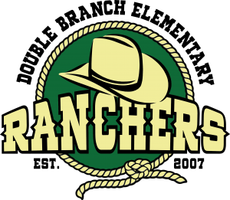

**Mrs. Cruz’s**

**Pre-K VE SUPPLY LIST 2025-2026**

**Requested Supplies:**

3 packs of baby wipes (no refills, unopened)

2 cans of Lysol aerosol spray disinfectant

2 rolls of paper towels (unopened in original wrapper)

2 boxes of tissues

1 white 1 inch binder with clear cover

1 box of gallon size zip lock bags

2 large containers of disinfectant wipes

1 box of powder-free rubber disposable gloves 100 count size Large

1 box of scented dryer sheets

**\*Child’s personal supplies:**

*Regular size backpack (labeled)

*Water bottle (labeled)

*Lunch box (if needed for packed lunch, snacks from home, labeled)

*If your child uses diapers, please send a supply of diapers

*2 sets of clothes in a bag (labeled; please include socks, underwear, and outfits)

*1 clear shoebox size storage container with lid to store their extra clothing, diapers, etc.

*Foldable nap mat

*Small blanket/pillow/naptime buddy

**Thank you,**

**Mrs. Cruz**