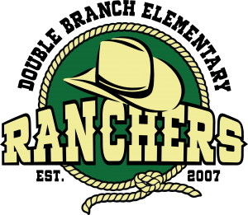

Double Branch Elementary

The Trailblazers 2nd Grade Supply List

2025-2026 School Year

*Prior to the first day of school, please label all starred (*) items with your child’s name.*

* 1- plastic pencil box (8.5 inches x 5.5 inches)*
* 1- pair of pointed tip scissors*
* 1- pair of headphones (***These are used on a daily basis***)*
* 1- box of Kleenex
* 1- roll of paper towels
* 1- box of bandaids (girls only)
* Post it notes (boys only)
* 1- container of baby wipes
* 2- container of disinfecting wipes
* 12- Chisel tip dry erase black Expo markers (girls only)
* 12- Fine tip dry erase black Expo markers (boys only)
* 36- **sharpened** #2 pencils
* 1- package of pink erasers or pencil cap erasers
* 2- box of 24 count Crayola crayons
* 1- box of thin markers (girls only)
* 6- small glue sticks (No bottles of glue, please!)
* 2- 1.5 inch **white** 3 ring binder with 2 interior pockets and a clear view overlay on the front
* Sheet protectors (boys only)
* 3-notebooks (2-wide ruled composition and 1-primary composition)
* 4- **plastic** 2 pocket folders with prongs (1 of each color: blue, red, green, yellow)

Wishlist: highlighters, index cards, colored EXPO markers, copy paper; jumbo sized slider Ziploc bags, Magic erasers, address labels (1” x 2 5/8”), shipping labels (2” x 4” and 5 ½ x 8 ½)