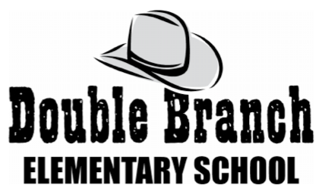

**First Grade Supply List 2024-2025**

Below is a list of supplies needed to begin the school year. Bringing supplies in on “Meet the Teacher Day” is preferred and appreciated. Please place supplies in bags labeled with your child’s name on it. We will label the supplies inside the bags at school. Thank you all for your support!

* 2 black & white **or** blue & white **PRIMARY** composition books (**MUST** have a **picture** **box** **space** on top of each page)

* 2 reams of white copy paper

* 1 box of Crayola markers

* 1 box of sharpened pencils

* 1 hard plastic pencil box. **Please** **label** **with** **your** **child’s** **name**.

* 4 boxes of **sharpened** **#2** **pencils** (12 count or more Ticonderoga preferred)

* 1 pack of pencil-top erasers

* 3 packs of fat black Expo markers

* 3 packs of thin black Expo markers

* 4 boxes of Crayola crayons (24 pack)

* 1 pair of children’s scissors

* 12 glue sticks - (2) 6 packs

**\* 1 pair of headphones (in a plastic bag labeled with your child’s name, please.)**

- **These are very important and needed right away for testing purposes.**

* 2 boxes of tissues

* 1 roll of paper towels

* 4 **Plastic** folders with prongs (2 **red** and 2 **yellow**)

* 1 white 1 inch 3 ring binder

* 2 package of baby wipes

* 1box of BandAids (girls only)

* 1 box of sandwich size slide zip Ziploc bags (girls only)

* 1 box of Gallon size Ziploc slide zip bags (boys only)

* 1 container of Clorox/Lysol wipes (boys only)

**Wish List items:**

* Skinny multicolored highlighters (pink, orange, yellow, green, blue)

* Expo markers – colors

* Crayola twistable

* Additional boxes of Crayola crayons

* Additional glue sticks

*1 package of Magic Erasers

*Reams of white or colored copy paper

*Reams of white and/or colored cardstock

* Extra headphones