**Rats! Musical Costume Instructions**

**\*Please wear *tennis shoes* for safety on the risers and stage with your costume.**

**The setting of the story “Rats!” is an old folk tale that takes place during the 1200’s.** Students that are in the chorus/sign holders and recorder players are playing the part of the Townspeople: Here are some ideas. Please note: these are only ideas. Anything similar will be fine. 😊

Girls- please wear a long skirt and blouse or dress below the knee.

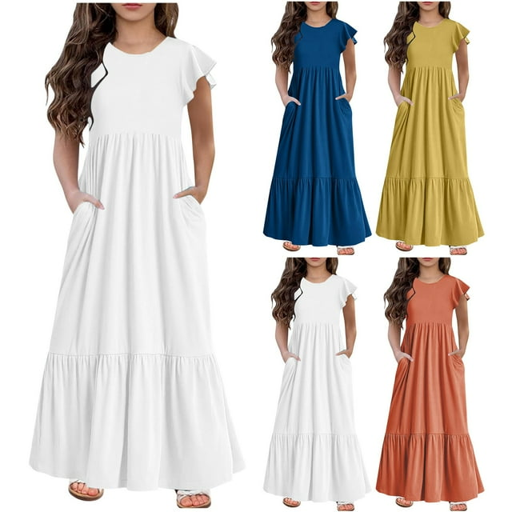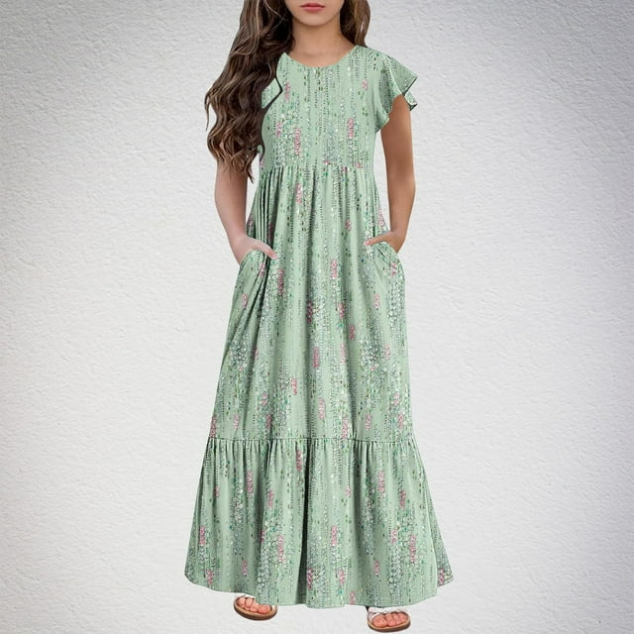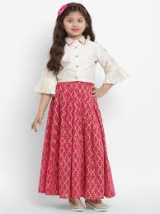

**Boys-** please wear a polo shirt or long-sleeved dress shirt with sleeves rolled up. Long pants or dress shorts. Optional ideas include: suspenders, hat (see examples below)

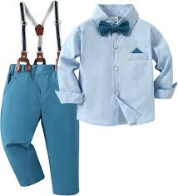

(no bow tie needed)