**Mrs. Lisa Grimsley** Principal [lgrimsle@pasco.k12.fl.us](mailto:lgrimsle@pasco.k12.fl.us)

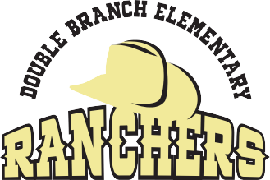

**Dr. Charlene Tidd** Assistant Principal [chartidd@pasco.k12.fl.us](mailto:chartidd@pasco.k12.fl.us)

**31500 Chancey Road • Wesley Chapel, Florida 33543 • (813) 346-0400 • (813) 346-0491 FAX**

March 11, 2025

Dear Parents/Guardians:

As part of our music curriculum at Double Branch Elementary, we strive to have a variety of performance opportunities for each grade level throughout the school year. We also give students many opportunities to practice appropriate concert manners so that when they leave our school, they are well-versed in what is expected from them as a performer or as an audience member.

We are excited to tell you that we are beginning to work on the 2nd and 3rd grade musical. **All of 2nd and 3rd grade will be performing a musical entitled “RATS!”** This musical will be performed here at Double Branch Elementary in our cafeteria. Because our 2nd and 3rd grades are so large, we will need to split our students into two groups.

**Please see the schedule below to see when your child’s class is performing.**

**Mark your calendars! Here are the dates:**

**April 22nd** The following classes will be performing 2 shows:

Benchoff, Joyce, Stalans, Glenn, Hamilton, Pramberger, Henderson

**April 24th** The following classes will be performing 2 shows:

Duguid, Lopez, Martel, Horner, Agnes, Morris, Levin

**Two shows and times on the same day!**

Performance #1: Students will be performing the musical for half of the school during the school day.

Performance #2: The performance for families and friends will take place in the cafeteria at Double Branch Elementary and will begin at **6:00 p.m.** that evening. Students will need to arrive in the music room at **5:40 p.m.** that evening to prepare.

Students are encouraged to visit the dbesmusic website to practice their songs. Don’t forget to submit what you practiced and help your grade level in the contest to see which grade level practices more! 😊

Details on costume ideas will be posted to the website in the upcoming weeks! We look forward to seeing you in April!

Sincerely,

Mrs. Jennifer Coyne & Miss Bethanie Collins

*Double Branch Elementary Music Teachers*

