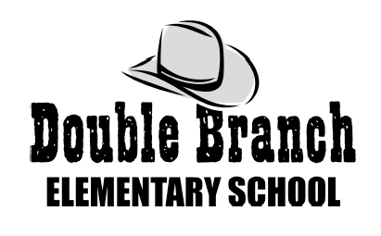

2024-2025 Kindergarten Supply List

Below is a list of supplies needed to begin the school year. Bringing supplies in on “Meet the Teacher Day” is preferred and appreciated. Please place supplies in bags labeled with your child’s name on it. We will label the supplies inside the bags at school. Thank you all for your support!

___ 24 Glue sticks ___ 1 Pencil Box (hard plastic 8x5)
___ 1 Pair of child scissors ___ 2 Rolls of paper towels
___ 1 Packs of baby wipes ___ 1 1-inch three ring white binder
___ 2 Boxes of tissues
___ 4 Boxes of 24 crayons
___ 2 ream of white copy paper
___ 1 pair of headphones (no earbuds
please)
___ 1 Bottle of hand sanitizer
___ 2 packs of Black Expo Markers
___ 1 box Snack Size Ziploc Bags
___ 2 box Quart Ziploc Bags
___ 36- sharpened No.2 pencils
___ 3 plastic/vinyl folders without prongs (Red, Blue, and Yellow)
___ 1 Wide Ruled Primary Composition Book

Wish List: extra pencils, Mr. Sketch Markers,
Expo Markers, glue sticks, color copy paper, Lysol wipes, white card stock, magic erasers, and hand sanitizer are always appreciated!

