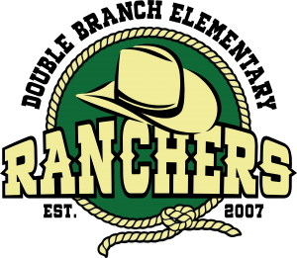
Double Branch Elementary
The Trailblazers 2nd Grade Supply List
2024-2025 School Year

Prior to the first day of school, please label all starred (*) items with your child’s name.

- 1- plastic pencil box (8.5 inches x 5.5 inches)*
- 1- pair of scissors*
- 1- pair of headphones (These are used on a daily basis)*
- 2- box of Kleenex
- 2- roll of paper towels
- 1- box silder zipper quart sized Ziploc bags (boys only)
- 1- box slider zipper sandwich sized Ziploc bags (girls only)
- 1- box of bandaids (girls only)
- 1- container of baby wipes
- 1- container of disinfecting wipes
- 12- dry erase black Expo markers
- 36- sharpened #2 pencils
- 1- package of pink erasers or pencil cap erasers
- 2- box of 24 count Crayola crayons
- 1- box of colored pencils
- 6- small glue sticks (No bottles of glue, please!)
- 1- package of wide ruled filler notebook paper (boys only)
- 2- composition notebooks (wide ruled lines)
- 3- plastic 2 pocket folders with prongs (1 of each color: red, blue, yellow)

Wishlist: colored EXPO markers, copy paper

