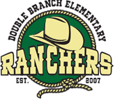

Mrs. Lisa Grimsley
Principal lgrimsle@pasco.k12.fl.us

Mrs. Tiffany Gocsik
Assistant Principal tgocsik@pasco.k12.fl.us

31500 Chancey Road • Wesley Chapel, Florida 33543 • (813) 346-0400 • (813) 346-0491 FAX

Dear Parents/Guardians,
Your child has expressed an interest in auditioning for All-County Elementary Chorus 2009. This is a wonderful musical experience for the students of our County. Students that are chosen to represent their school will be getting together for two Saturday rehearsals culminated by a concert at the River Ridge Performing Arts Center in New Port Richey. Students will have the opportunity to work with a wonderful clinician and will be singing in a chorus of approximately 150 students from throughout Pasco County. All-County Elementary Chorus will take place on April 18th and April 25th. April 18th our rehearsal will take place at Deer Park Elementary School. April 25th, our rehearsal and concert will be at River Ridge Performing Arts Center.
Each school may send 5 students to represent their school. We are going to be holding auditions for this special group on Tuesday February 10th. Auditions will take place in the music room at 8:30 a.m.
If you are interested in your child auditioning for this special group, please fill out the form below and return it to Mrs. Coyne and Mrs. Cobb by Monday February 9th. This will give us an idea of how many students we have that are interested in this group.

Thank you very much for your time!
Sincerely,

Mrs. Jennifer Coyne and Mrs. Dana Cobb

+++++++++++++++++++++++++++++++++++++++++++++++++++++++++++++++++

My Child_____________________________________________________________would like to audition for this group and will be at school on on Tuesday February 10th and will be in the music room at 8:30 a.m.

Thank you!

District Accreditation • Southern Association of Colleges and Schools
Council on Accreditation and School Improvement

August 14, 2026
Dear Parents/Guardians,
Your child has shown an interest in joining our 3rd-5th grade Orff Ensemble here at Double Branch.
Orff Ensemble is a small group of students that will meet on Tuesday and Thursday mornings before school. During this time, they will learn songs on instruments such as the xylophones, drums, and various other rhythm instruments in preparation for our concert. Rehearsals are mandatory each week, and students will be dismissed to their classes from the music room when the bell rings. If students are going to breakfast, they will be able to do so before going to their class.
To be a part of our Orff Ensemble, students will go through an audition process.

Students interested in auditioning should scan the QR code below to sign up for an audition day
OR type “dbes music” in Google, click on “A Music Page” and “Orff Page”. Sign-up will be on website.
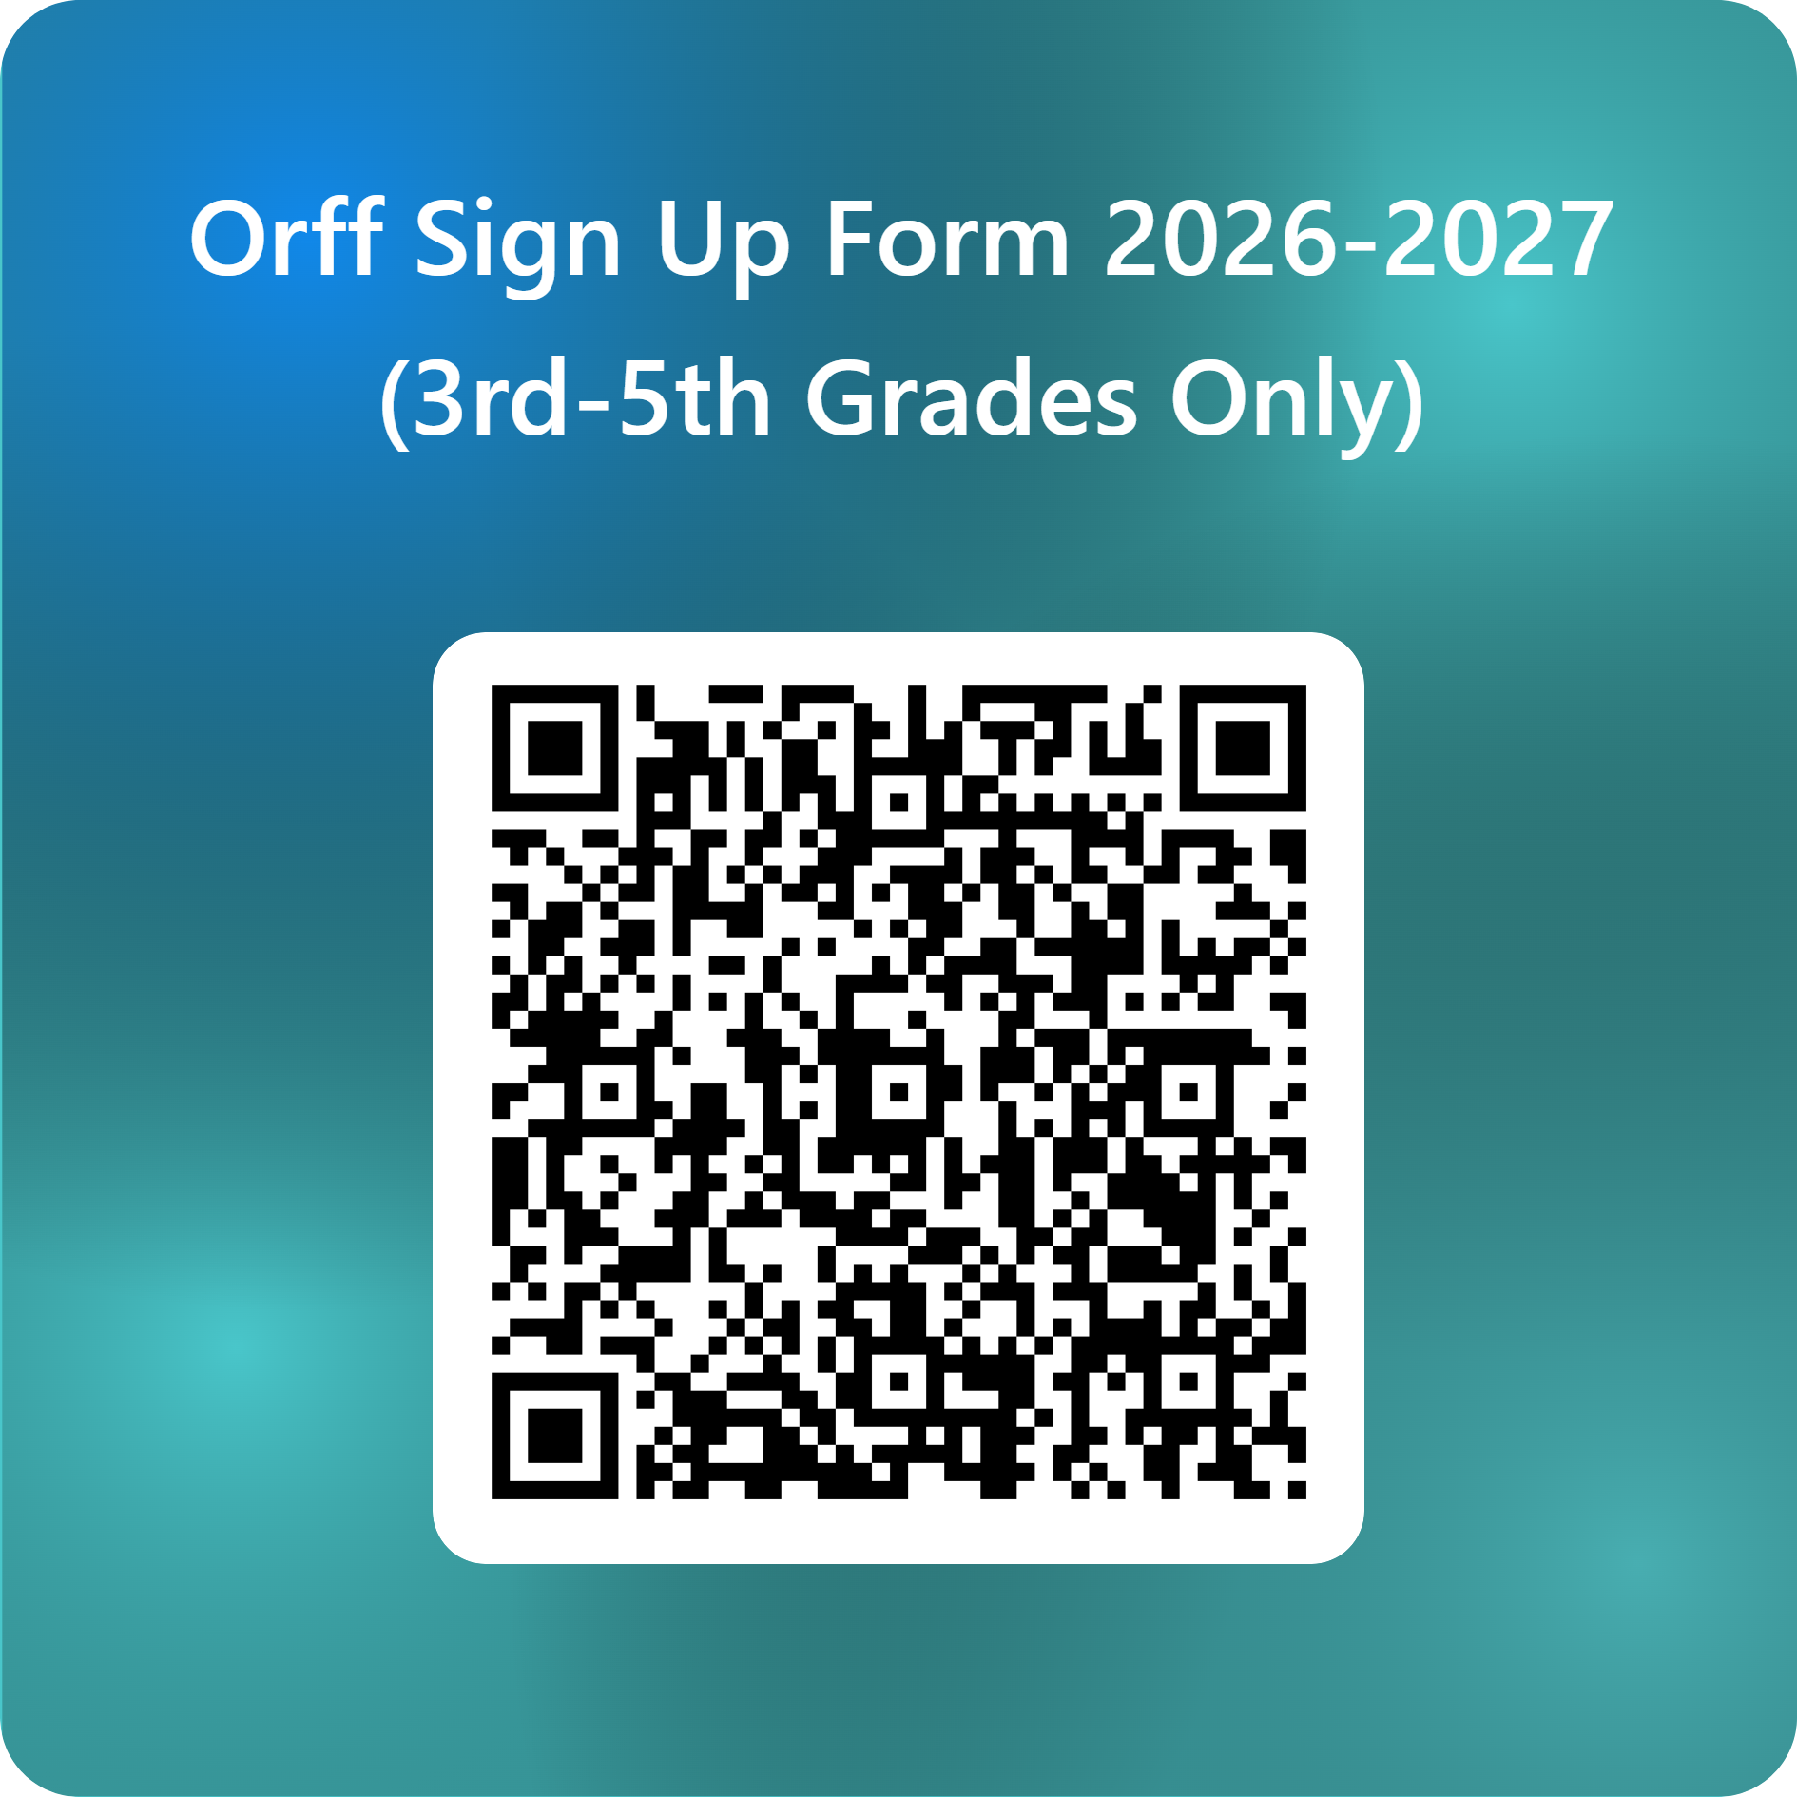

Audition Days: Tuesday August 25th
Wednesday August 26th
Thursday August 27th
Students that sign up for auditions will meet Mrs. Coyne at the front entry gate by the main office at 8:30 a.m. and will be escorted to the music room.

During the audition we are looking for students that can display the following:
-a good sense of steady beat
-can accurately clap various rhythmic patterns
-can hear and see a pattern being played on an instrument and play it back
-can keep a pattern going while other patterns are being played.
-can look at a piece of music with minimal instruction and begin to figure out how to play it on their own.
- have a “never give up” attitude
- are willing to work hard and give it their all!

After the auditions, students that are selected for the Orff Ensemble will receive a letter from us stating when rehearsals will begin, concert dates etc.
If you have any questions, please feel free to contact us at any time.
We look forward to working with your children and a wonderful year at Orff Ensemble!

Thank you!
Sincerely,
Mrs. Coyne
jcoyne@pasco.k12.fl.us

